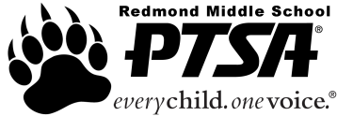
444Redmond Middle School PTSA 2.8.80
Check/Reimbursement Request Form
School Year 2018 - 2019

Use this form to receive reimbursement when you have spent funds on behalf of PTSA or to pay a vendor directly.
For questions, please contact treasurer@rmsptsa.org

Receipts or invoice must be attached!

Your Name Phone #

Date of Request Amount Requested

Activity/Committee Budget to be charged

Item(s) Purchased

Make Check Payable to

Mail Check to this Address

Any Special Instructions

Signature of Person Submitting Request

Remember, to receive payment, a receipt or invoice must be attached.

Treasurer’s Notes:

Check #
Check Date
Date Mailed
Account Charged

